**Update – PA Compact – 19 States – North Carolina becomes the 19th - State.**
PA Licensure Compact
What is the PA Compact?
The PA Compact is an interstate occupational licensure compact for physician assistants/associates (PAs). The compact facilitates multistate practice for PAs, improves health care access for patients, and enhances public protection.
States joining the compact agree to recognize a valid, unencumbered license issued by another compact member state via a compact privilege. Licensed PAs utilizing the compact can obtain a privilege in each compact member state where they want to practice.
PAs using a compact privilege must adhere to the laws and regulations of the state in which they are practicing.
For a history of the development of the PA Compact and the methodology used, please see our compact history page.
How the Compact Works for PAs
1. The PA meets the compact eligibility requirements:
- Active, unencumbered license from a compact member state
- Graduation from an accredited PA program
- Current NCCPA certification
- No felony or misdemeanor conviction
- Other requirements as defined in the compact model legislation
2. The PA submits an application to the PA Compact Commission for a privilege to practice in another compact member state
- After receipt of the application, the PA’s license and eligibility are verified via the compact data system.
- The PA pays a compact privilege fee and completes any jurisprudence requirements.
3. The compact privilege is issued to the PA. The PA now has the legal authorization to practice in a compact state
- The compact privilege is issued by the remote compact member state via the compact commission.
- The PA must follow the laws and regulations of the compact member state where the patient is located/services are delivered.
PA Compact Benefits
Benefits for PAs:
- Facilitates multistate practice through a streamlined process (a compact privilege to practice).
- Expands employment opportunities into new markets.
- Improves continuity of care when patients or providers relocate.
- Supports relocating military spouses.
Benefits for State Regulators:
- Reduces application processing time.
- Facilitates cross-state licensure board cooperation on investigations and disputes.
- Enhances public safety through a shared data system.
- Authorizes states to charge an initial and renewal fee for a compact privilege.
- Preserves the current state-based licensure system (i.e. scope of practice and initial licensure process).
Benefits for States:
- Promotes workforce development and strengthens labor markets.
- Expands patient access to highly qualified practitioners.
- Preserves state sovereignty.
- Increases collaboration among states.
- Facilitates practitioner mobility during public health emergencies.
Timeline
Interstate compacts take time to develop and implement because of the coordination necessary among state legislatures, state regulatory boards and the compact commission. The following timeline represents the PA Compact’s development history as well as its projected dates to become operational.
Summer 2019 | Compact project started.
Fall 2019 | FSMB convenes meeting with state regulatory boards to discuss outline of compact.
November 2022 | Compact legislation finalized and made available for state adoption.
May 2024 | The compact activation threshold of seven participating states is met.
September 2024 | Compact Commission to hold inaugural meeting.
Early 2026 (projected) | Compact Commission begins granting compact privileges to practice.

What’s Next?
The compact has reached its activation threshold of seven states. The compact commission will inaugurally be convened in September 2024 to begin work to operationalize the compact.
Additional states continue to consider and enact compact legislation.
PA Compact Status
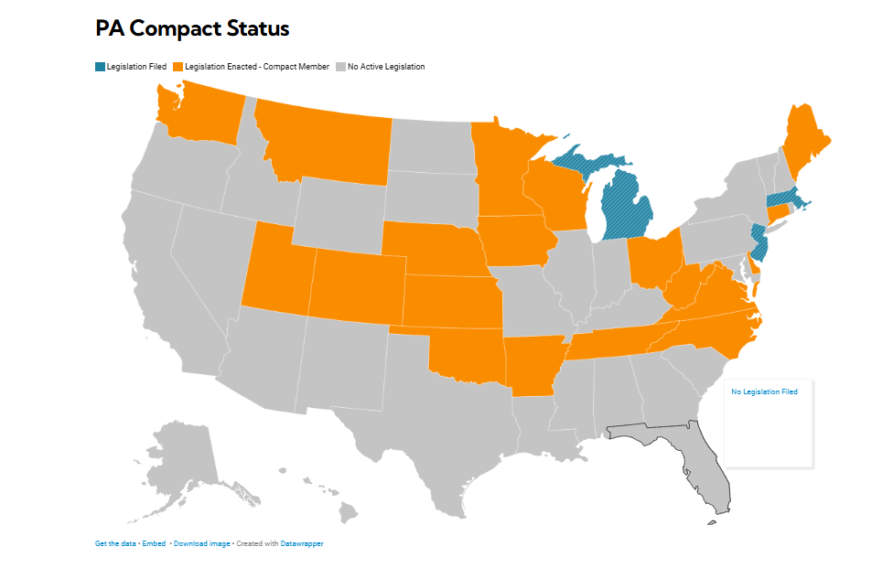

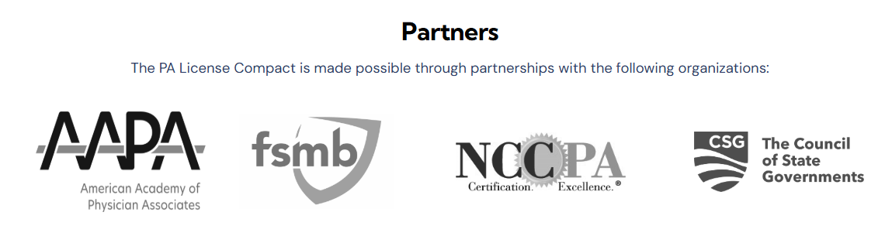

How can you help?
More Information: pacompact@csg.org
PA Compact Tool Kit: https://www.pacompact.org/compact-toolkit/
Contact your legislators: How to find your elected officials….
https://www.usa.gov/elected-officials

Update – PA Compact – 18 States - Connecticut becomes the 18th 27 June 2025.

