More Specific Information available at AAPA - https://www.aapa.org/advocacy-central/state-advocacy/state-maps/pa-state-practice-environment/

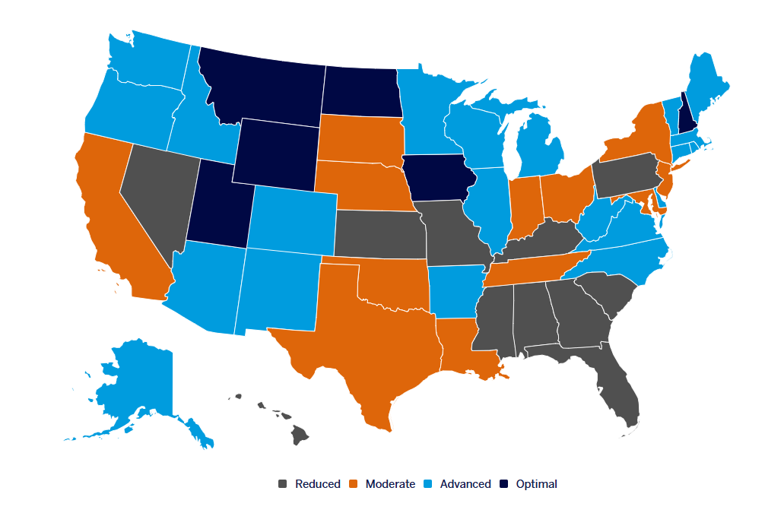
Current State Practice Environment – January 2025- AAPA Data source.

Practice Categories
Optimal – PAs can practice to the full extent of their medical education, training, and experience. PAs continue to collaborate, consult, and/or refer to the appropriate member(s) of the healthcare team as indicated by the patient’s condition, the PA’s competencies, and the standard of care. The healthcare team, and/or their employer, may establish guidelines for collaboration, consultation, and/or referral beyond state laws and regulations.
Advanced – PAs practice to the full extent of their medical education, training, and experience, but must comply with additional administrative requirements as mandated in state law and/or regulation.
Moderate – State law and/or regulation requires additional administrative burdens that impact the practice environment. The PA and the healthcare team are limited in flexibility due to these administrative burdens.
Reduced – State law and/or regulation restrict the healthcare team and PAs’ ability to practice in at least one element of PA practice. Requires outdated practice models of limited delegated authority and/or restrictive supervision requirements.

