APRN – NP Compact Status - Inactive until 7 States enact legislation
What is the APRN Compact?
The compact will benefit APRNs, patients and health care providers by creating one multistate license. This increases access to care by allowing APRNs to care for patients across state lines—both in person and electronically. The APRN Compact provides public protection by establishing uniformity in the way APRNs are regulated at the state level. A compact license will save APRNs from the unnecessary time and cost of obtaining additional licenses

Benefits of the APRN Compact
- Access to Care: Increases access to APRN services across the country quickly and efficiently, which is essential for the health of many rural and underserved communities.
- Telehealth: Enables APRNs to practice in person or provide telehealth services to patients located across the country seamlessly and efficiently. Disaster/Pandemic Relief: Allows APRNs to immediately cross state borders and provide vital services in the event of an emergency, without the need to wait for executive declaration.
- Military Families: Allows military spouse APRNs to seamlessly continue working upon relocation and change of employment.
- Online Education: Facilitates online nursing education.
- Cost Effective: § For APRNs: APRNs do not have to obtain additional nursing licenses, making practicing across state borders affordable and convenient.
For Employers:
- The APRN Compact also removes a burdensome expense for organizations that employ APRNs and may share the expenditure of obtaining and maintaining multiple licenses.
For States:
- Flexible Licensure: Allows APRNs to obtain or maintain a single state license if preferred.

Uniform Licensure Requirements: APRN Compact Multistate License
Requirements:
An applicant for licensure in a state that is a part of the APRN Compact will need to meet the following uniform licensure requirements:
1. Meets the requirements for licensure in the home state (state of residency).
2. i. Has graduated from an accredited graduate-level education program that prepares the applicant for one of the four recognized APRN roles and population foci; or
ii. Has graduated from an international APRN education program for one of the four recognized APRN roles and population foci (approved by the authorized accrediting body in the applicable country and verified by an independent credentials review agency).
3. Has passed an English proficiency examination, if a graduate of a foreign APRN education program not taught in English or if English is not the individual’s native language.
4. Has successfully passed a national certification examination that measures APRN, role and population-focused competencies and maintains continued competence as evidenced by recertification in the role and population focus through the national certification program.
5. Holds an active, unencumbered license as a RN and an active, unencumbered authorization to practice as an APRN.
6. Has successfully passed an NCLEX-RN® examination or recognized predecessor examination.
7. Has practiced for at least 2,080 hours as an APRN in a role and population focus congruent with the applicant’s education and training. Practice shall not include hours obtained as part of enrollment in an APRN education program. **
8. Has submitted to state and federal fingerprint-based criminal background checks.
9. Has not been convicted or found guilty, or has entered into an agreed disposition, of a felony offense under applicable state, federal or foreign criminal law.
10. Has no misdemeanor convictions related to the practice of nursing (determined on a case by-case basis by the Commission).
11. Is not currently enrolled in an alternative program.
12. Is required to self-disclose current participation in an alternative program; and
13. Has a valid United States Social Security number.
**Please note: the 2,080 hours is completed under a single-state license. Importantly, the hours are not required to be under a collaborative, supervisory or mentorship relationship with any health provider. It is estimated that upwards of 90% of APRNs will meet this requirement upon the APRN Compact’s enactment.

APRN – NP Compact Status - Inactive until 7 States enact legislation
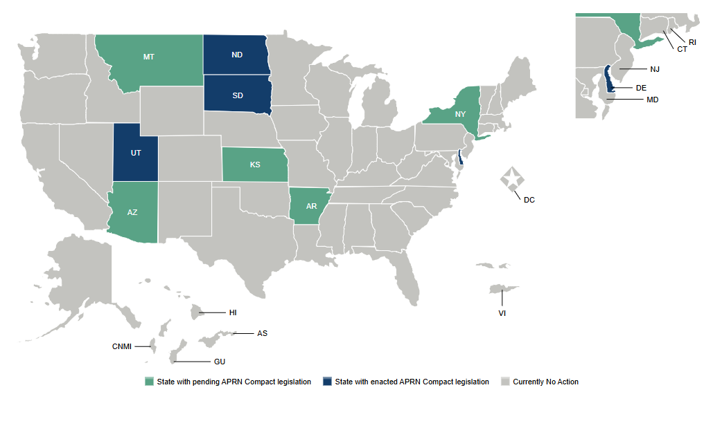

How can you help? Support the movement - https://www.aprncompact.com/take-action.page
More Information: https://www.aprncompact.com/stay-informed.page
Contact your legislators: How to find your elected officials….
https://www.usa.gov/elected-officials

